BOOKINGS: Total bookings per ground

$GROUP

{

_id: "$ground_id",

totalBookings: {

$sum: 1

}

}

OUTPUT:

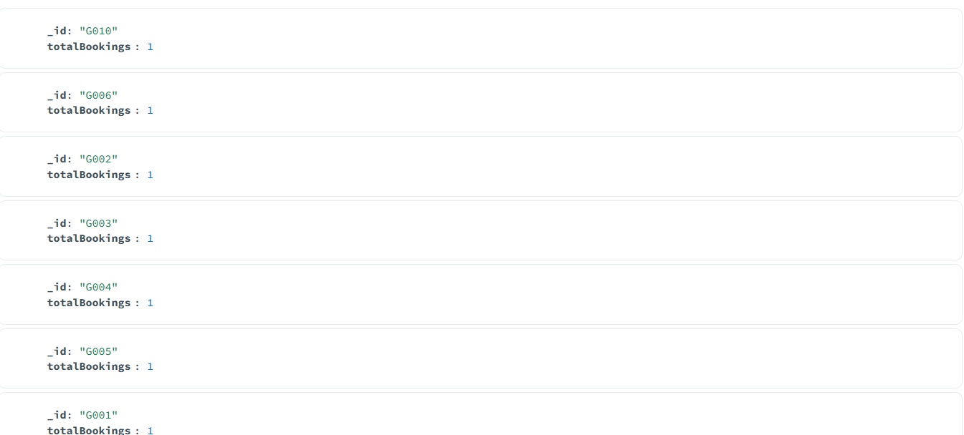

GROUNDS: Capacity utilization (with number of bookings)

$LOOKUP

{

from: "bookings",

localField: "ground_id",

foreignField: "ground_id",

as: "booking_details"

}

$ADDFIELDS

{

number_of_bookings: {

$size: "$booking_details"

},

capacity_utilization_percentage: {

$cond: {

if: {

$gt: ["$capacity", 0]

},

then: {

$multiply: [

{

$divide: [

"$number_of_bookings",

"$capacity"

]

},

100

]

},

else: 0

}

}

}

$PROJECT

{

_id: 0,

ground_id: 1,

name: 1,

location: 1,

capacity: 1,

number_of_bookings: 1,

capacity_utilization_percentage: 1

}

OUTPUT:

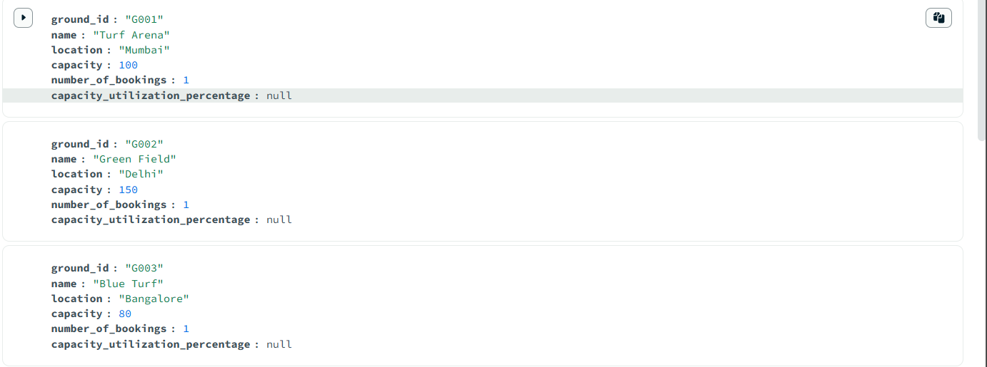

**Matches** — Matches per tournament with ground name

$LOOKUP

{

from: "grounds",

localField: "ground_id",

foreignField: "ground_id",

as: "ground_info"

}

$UNWIND

"$ground_info"

$GROUP

{

_id: "$tournament_id",

matches: {

$push: {

match_id: "$match_id",

date: "$date",

teams: "$teams",

winner_team: "$winner_team",

ground_name: "$ground_info.ground_name"

}

}

}

OUTPUT:

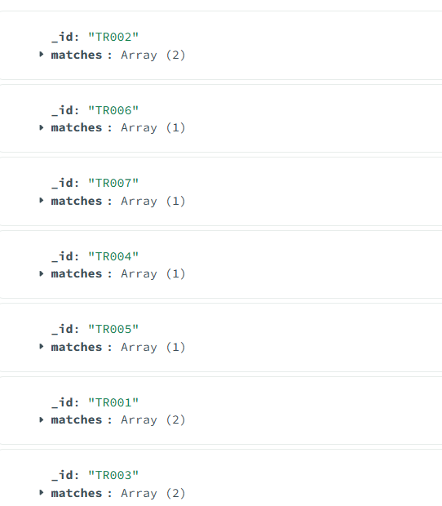

**Players** — Player count by team

$GROUP

{

_id: "$team_id",

player_count: {

$sum: 1

}

}

OUTPUT:

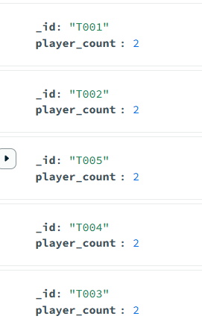

**Tournaments** — List tournaments with organizer name

$LOOKUP

{

from: "organizers",

localField: "organizer_id",

foreignField: "_id",

as: "organizer_info"

}

$ADDFIELDS

{

organizer_name: {

$arrayElemAt: ["$organizer_info.name", 0]

}

}

$PROJECT

{

teams: 1,

name: 1,

tournament_id: 1,

start_date: 1,

organizer_name: 1

}

OUTPUT:

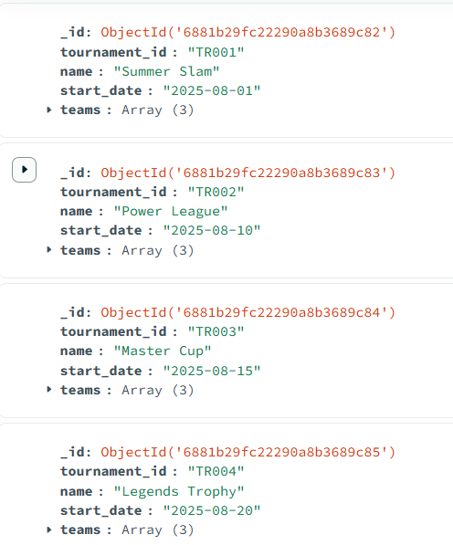

**Users** — Number of tournaments organized by each user

$MATCH

{

role: "organizer"

}

$GROUP

{

_id: "$user_id",

tournamentsOrganized: {

$sum: 1

}

}

OUTPUT:

